UNIVERSITY OF RWANDA

COLLEGE OF SCIENCE AND TECHNOLOGY

DEPERTMENT OF CHEMISTRY

BIO ORGANIC CHEMISTRY

LEVEL TWO

DUSHIMIYERA PROMESSE

Reg no: 219002100

Recturer :Dr Gasipard NZABAMWITA

POLYMER CHEMISTRY AND TECHNOLOGY ASSIGNMENT 5

Q: Differentiate with examples the mechanisms between step growth and chain growth polymerization reactions:

Chain-Growth Polymerization

In a **chain growth** polymerization, monomers become part of the polymer one at a time, for example the [anionic polymerization](http://www.pslc.ws/mactest/anionic.htm) of styrene to make [polystyrene](http://www.pslc.ws/mactest/styrene.htm).

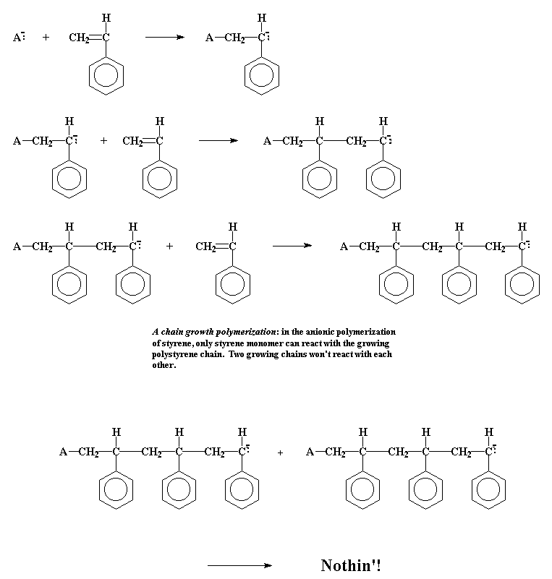

But in a **step growth** polymerization, things are more complicated

**For example:**

* polymerization of terephthoyl chloride and ethylene glycol, to make a [polyester](http://www.pslc.ws/mactest/pet.htm) called poly(ethylene terephthalate)
  + The first thing that happens is that the two monomers will react to form a dimmer

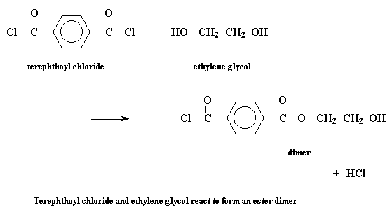

The dimer can do a lot of different things. It can of course react with one of the monomers to form a trimer:

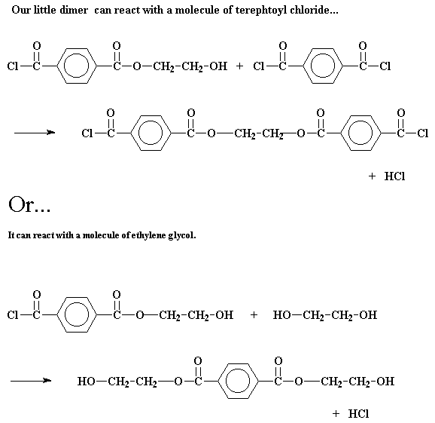

With chain polymerization, what are termed vinyl polymers are obtained, because the monomers from which it starts contain the vinyl group: (CH2 CH ), in which the C C double bond is present. The polymerization of vinyl monomers occurs by rupture of the double bond and creation of a simple covalent bond with the nearby monomer. Schematically:

2C=C→-C-C-C-C-

Usually an *initiator* compound reacts with the monomer to start the reaction, and the mechanism of chain polymerization consists of three phases, called *initiation*, *propagation,* and *termination*.

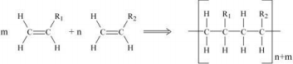In a chain growth polymerization:

∙ only monomers react with growing chains

∙ Two growing chains can't join together the way they can in a step growth polymerization

While in step growth polymerization:

∙ the growing chains may react with each other to form even longer chains

∙ This applies to chains of all lengths

∙ The monomer or dimer may react in just the

same way as a chain hundreds of monomer units

long